**01.LG_Classification_Final_Module_Assignment**

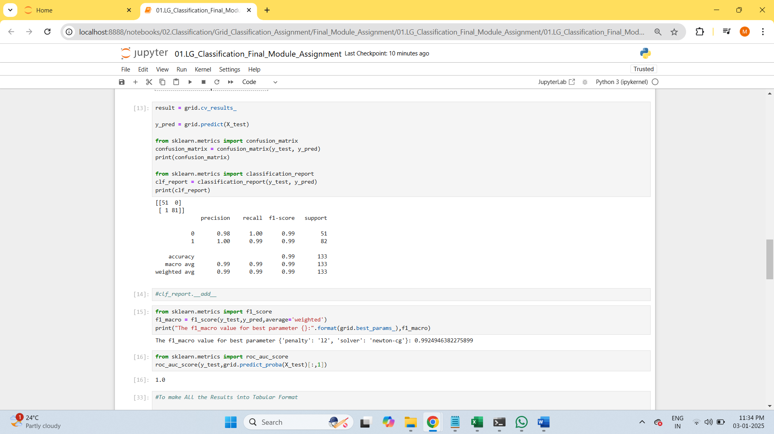

**02.SVM_Grid_Classification**

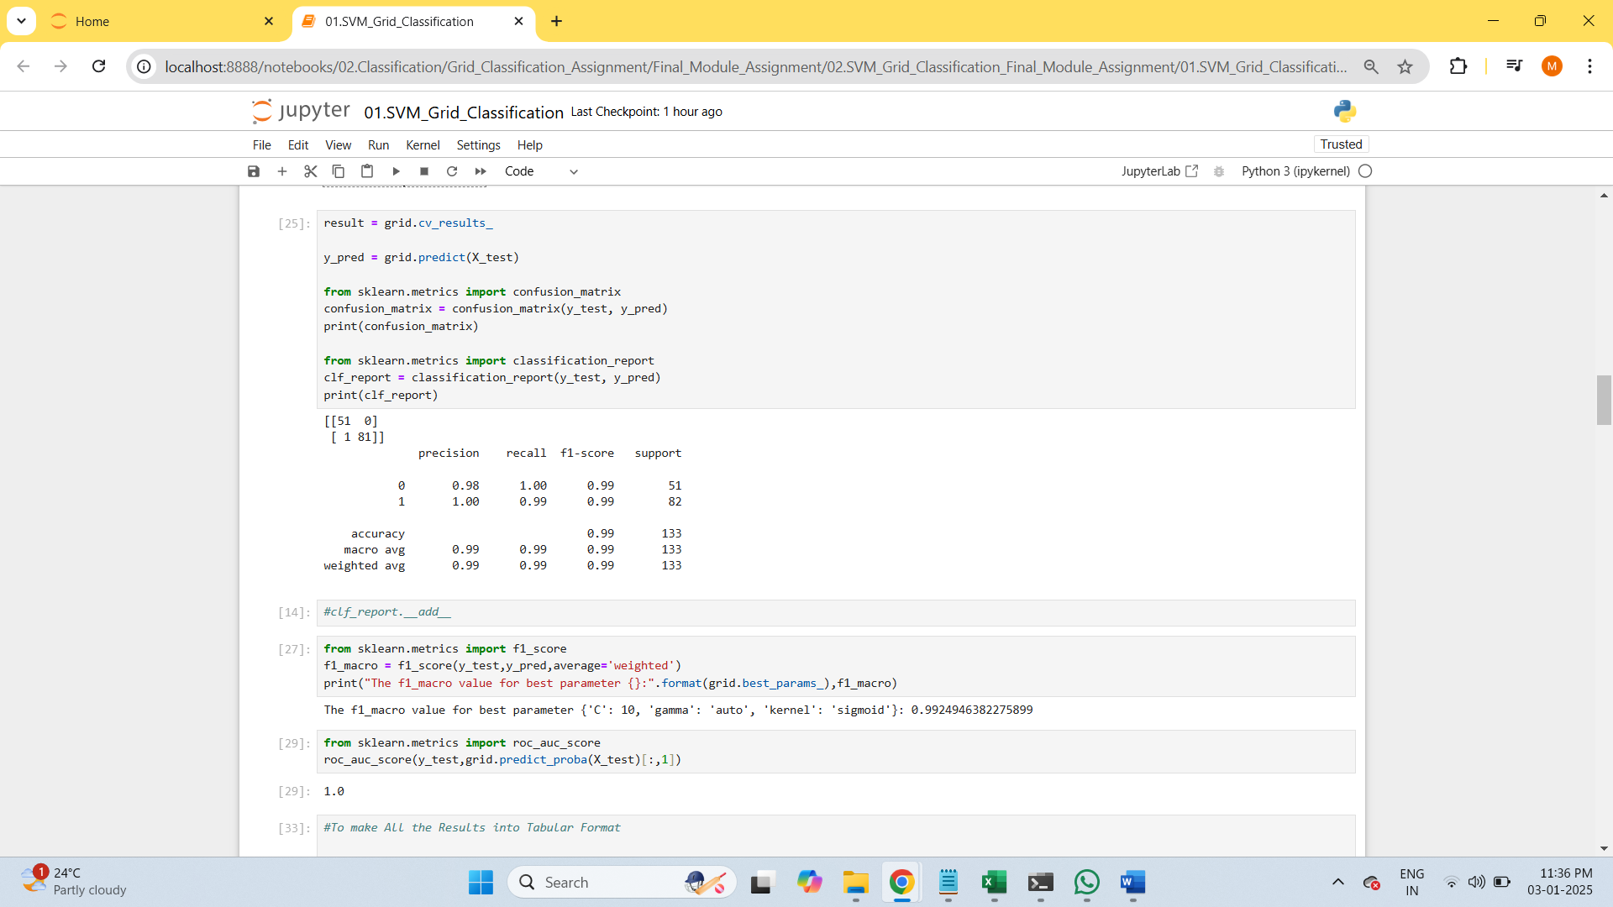

**03.Decision_Tree_Grid_Classification_Final_Module_Assignment**

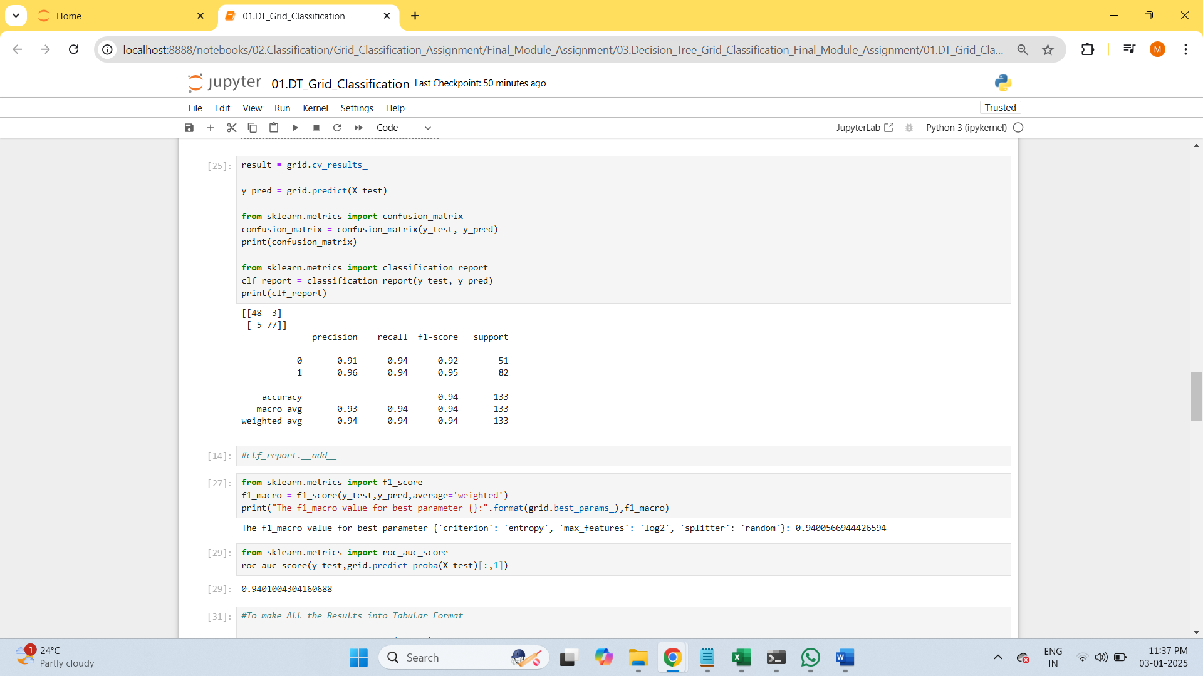

**04.Random_Forest_Grid_Classification_Final_Module_Assignment**

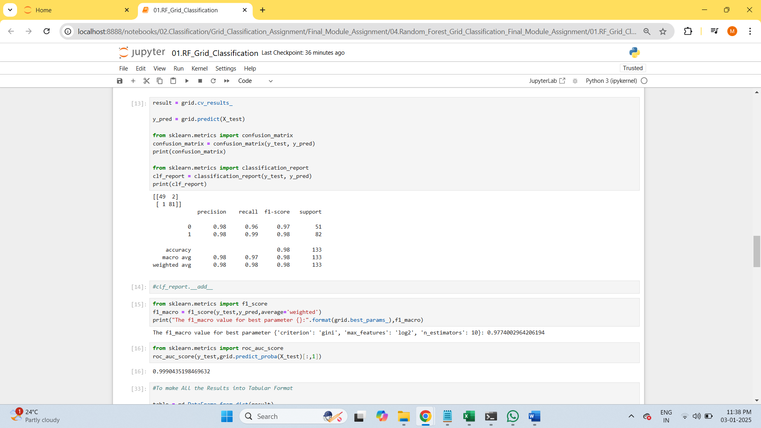

**Overall Result**

* The Best Model would be saved as Deployment Phase for the One which has Both the **Highest Accuracy Value and roc_auc_score** as Highlighted Below :

|  |  |  |  |  |
| --- | --- | --- | --- | --- |
| **S.No** | **Type of Classification** | **Hyper Tuned Parameters** | **Accuracy** | **roc_auc_score** |
| **1** | **LG** | **param_grid = {'solver':['newton-cg','lbfgs','liblinear','saga'], 'penalty':['l2']}** | **0.99** | **NA** |
| **2** | **SVM** | **param_grid = {'kernel':['linear','rbf','poly','sigmoid'], 'gamma':['auto','scale'], 'C':[10,100,1000,2000,3000]}** | **0.99** | **1.00** |
| **3** | **Decision Tree** | **param_grid = {'criterion':['gini','entropy'], 'max_features': ['auto','sqrt','log2'], 'splitter':['best','random']}** | **0.94** | **0.94** |
| 4 | Random Forest | param_grid = {'criterion':['gini','entropy'], 'max_features': ['auto','sqrt','log2'], 'n_estimators':[10,100]} | **0.98** | **0.99** |